Tutorial 8 - SPM (wk13 - done)

Question 1
Lim Zheng Ming
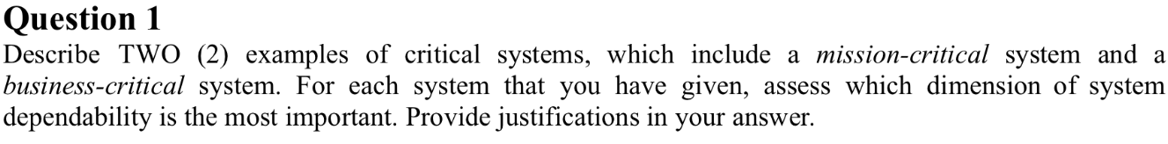

For revision***
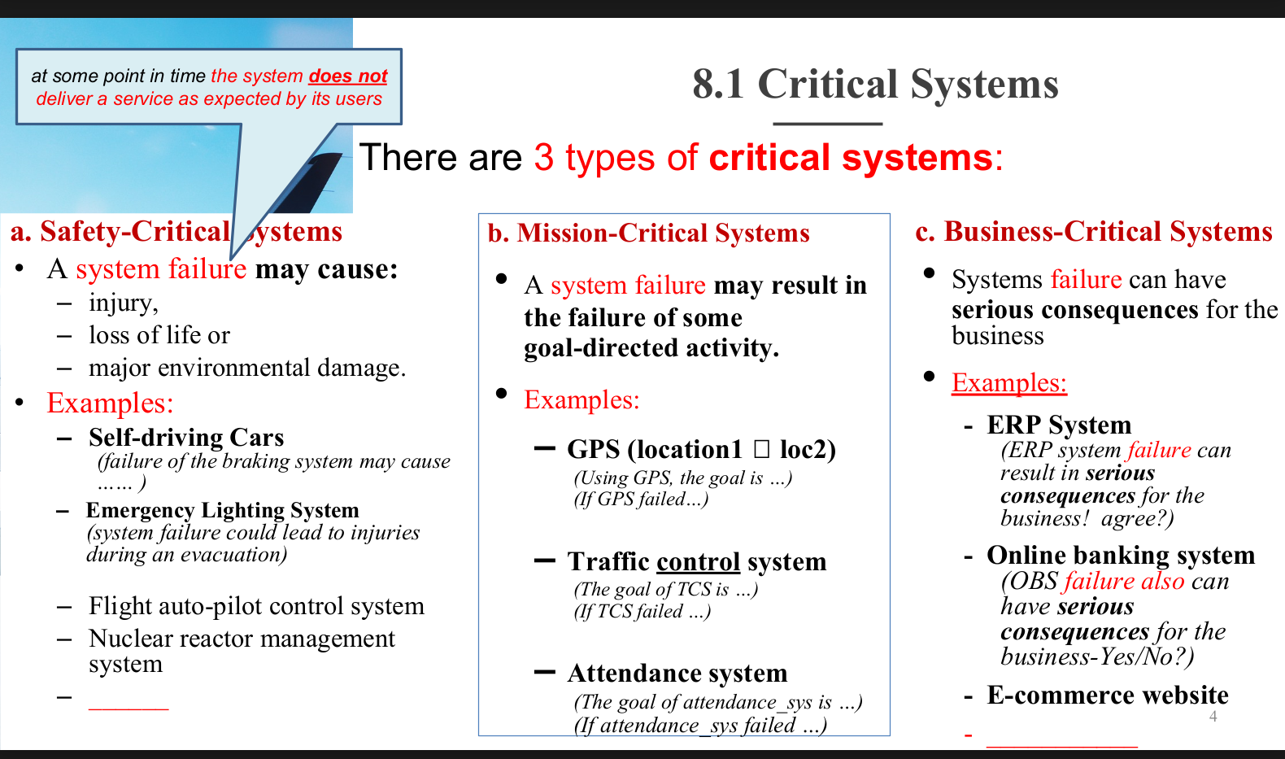
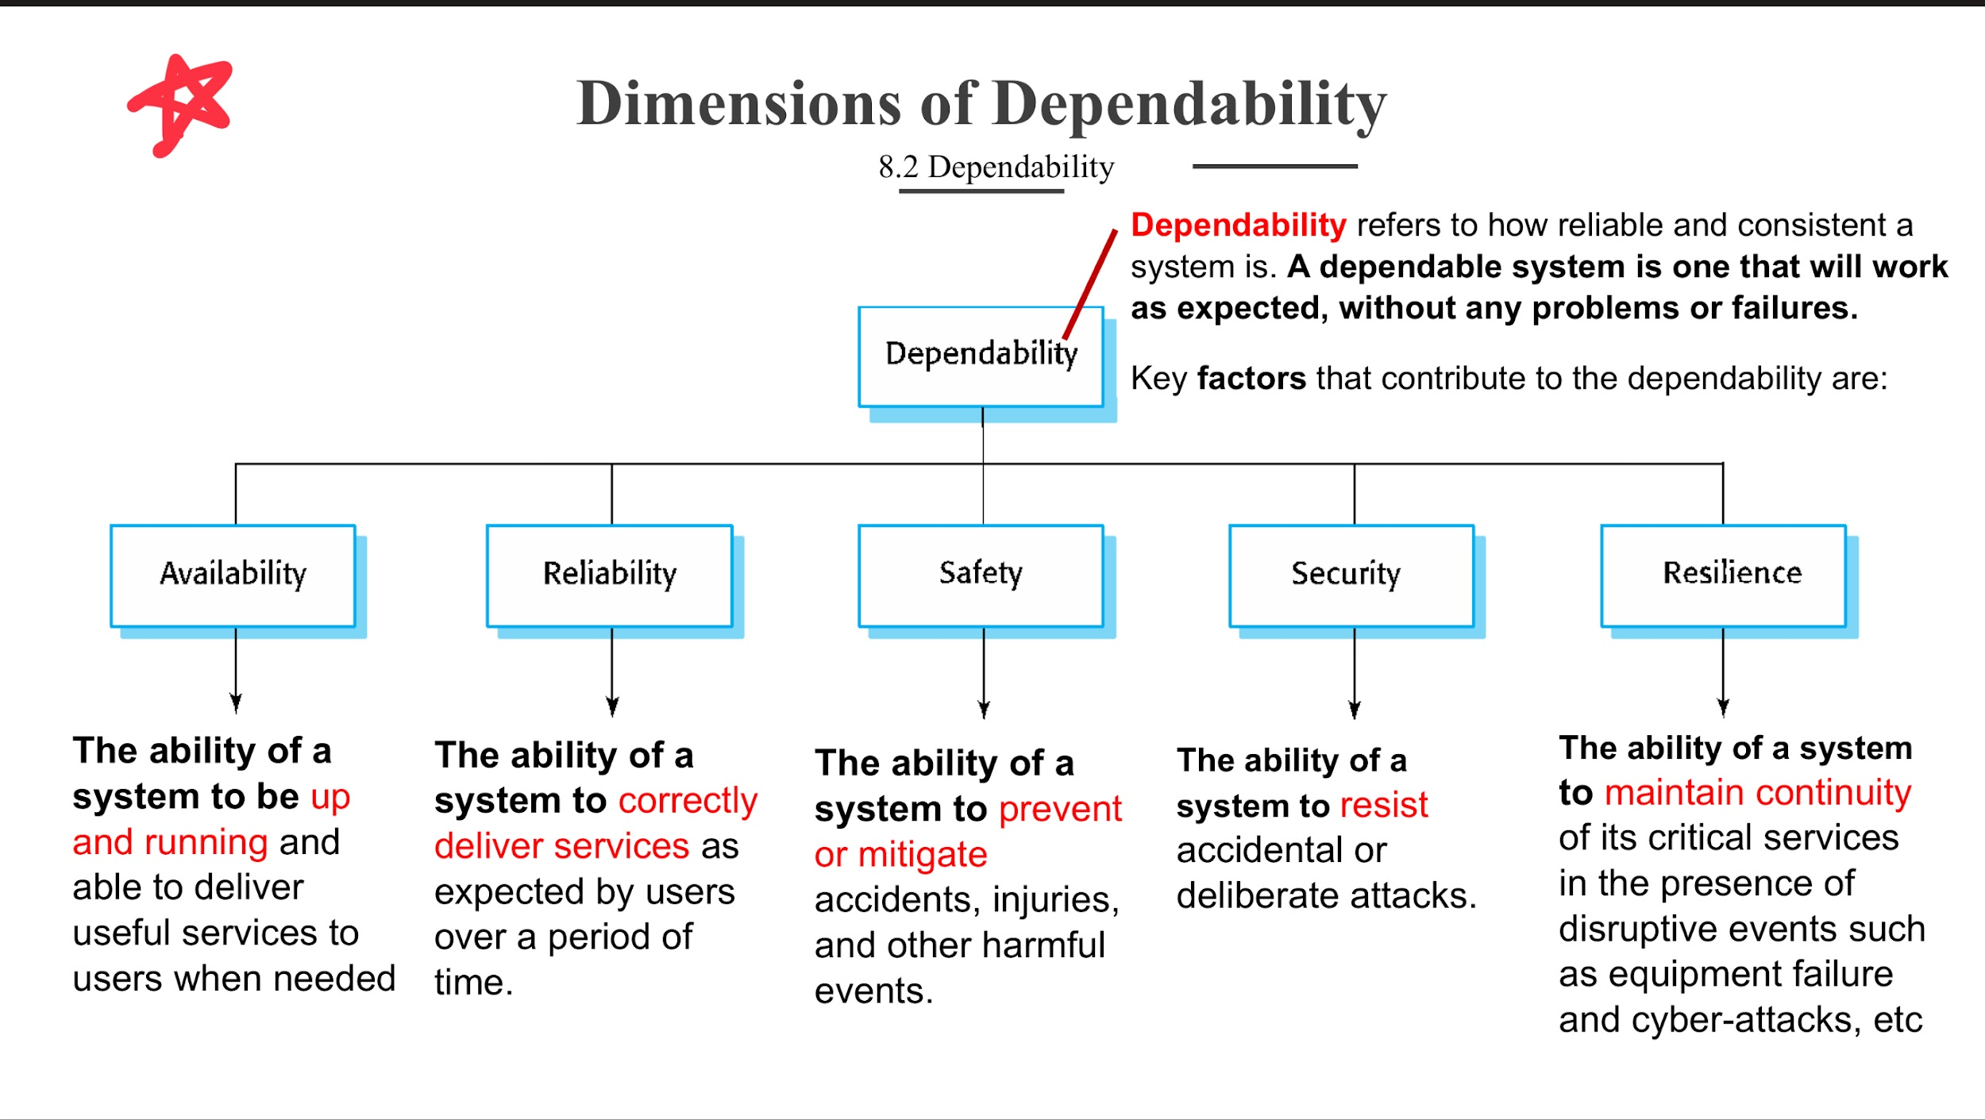
- Mission-Critical System - A system failure may result in the failure of some goal-directed activity: Air Traffic Control (ATC) System
ATC systems coordinate aircraft in flight and on the ground to prevent collisions, maintain efficient flight paths, and ensure passenger safety.
- Most Important Dimension of Dependability: Reliability. (security also can)
- Reliability：The ability of a system to correctly deliver services as expected by users over a period of time.
Any failure in delivering accurate flight path data or communication can lead to mid-air collisions or near misses. The system must consistently deliver correct services over time. Safety is critical too, but reliability underpins it—if the system consistently fails, safety cannot be achieved.

2. Business-Critical System - a system failure can have serious consequences for the business: Online Banking System
Banking systems manage billions in financial transactions daily. Failures can result in economic losses, reputational damage, and legal consequences.
- Most Important Dimension of Dependability: Availability. (security and reliability also can)
- Availability - the ability of a system to be up and running and able to deliver useful services to users when needed.
Customers expect 24/7 access to transfer funds, pay bills, or withdraw cash. If the system is down, it directly impacts customer trust and the bank’s operations. Even a short outage during peak hours can cost millions in lost transactions and litigation

Question 2
Tan Wen Tik
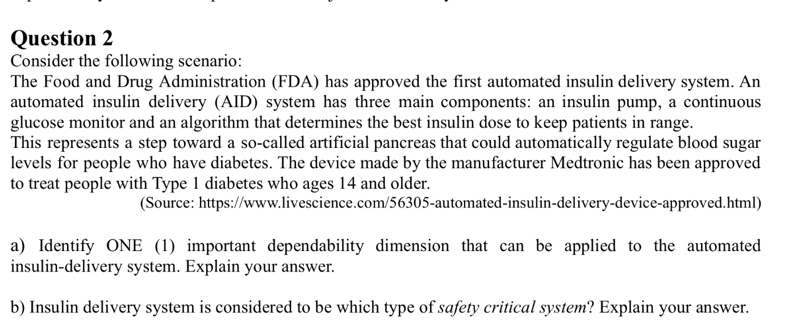
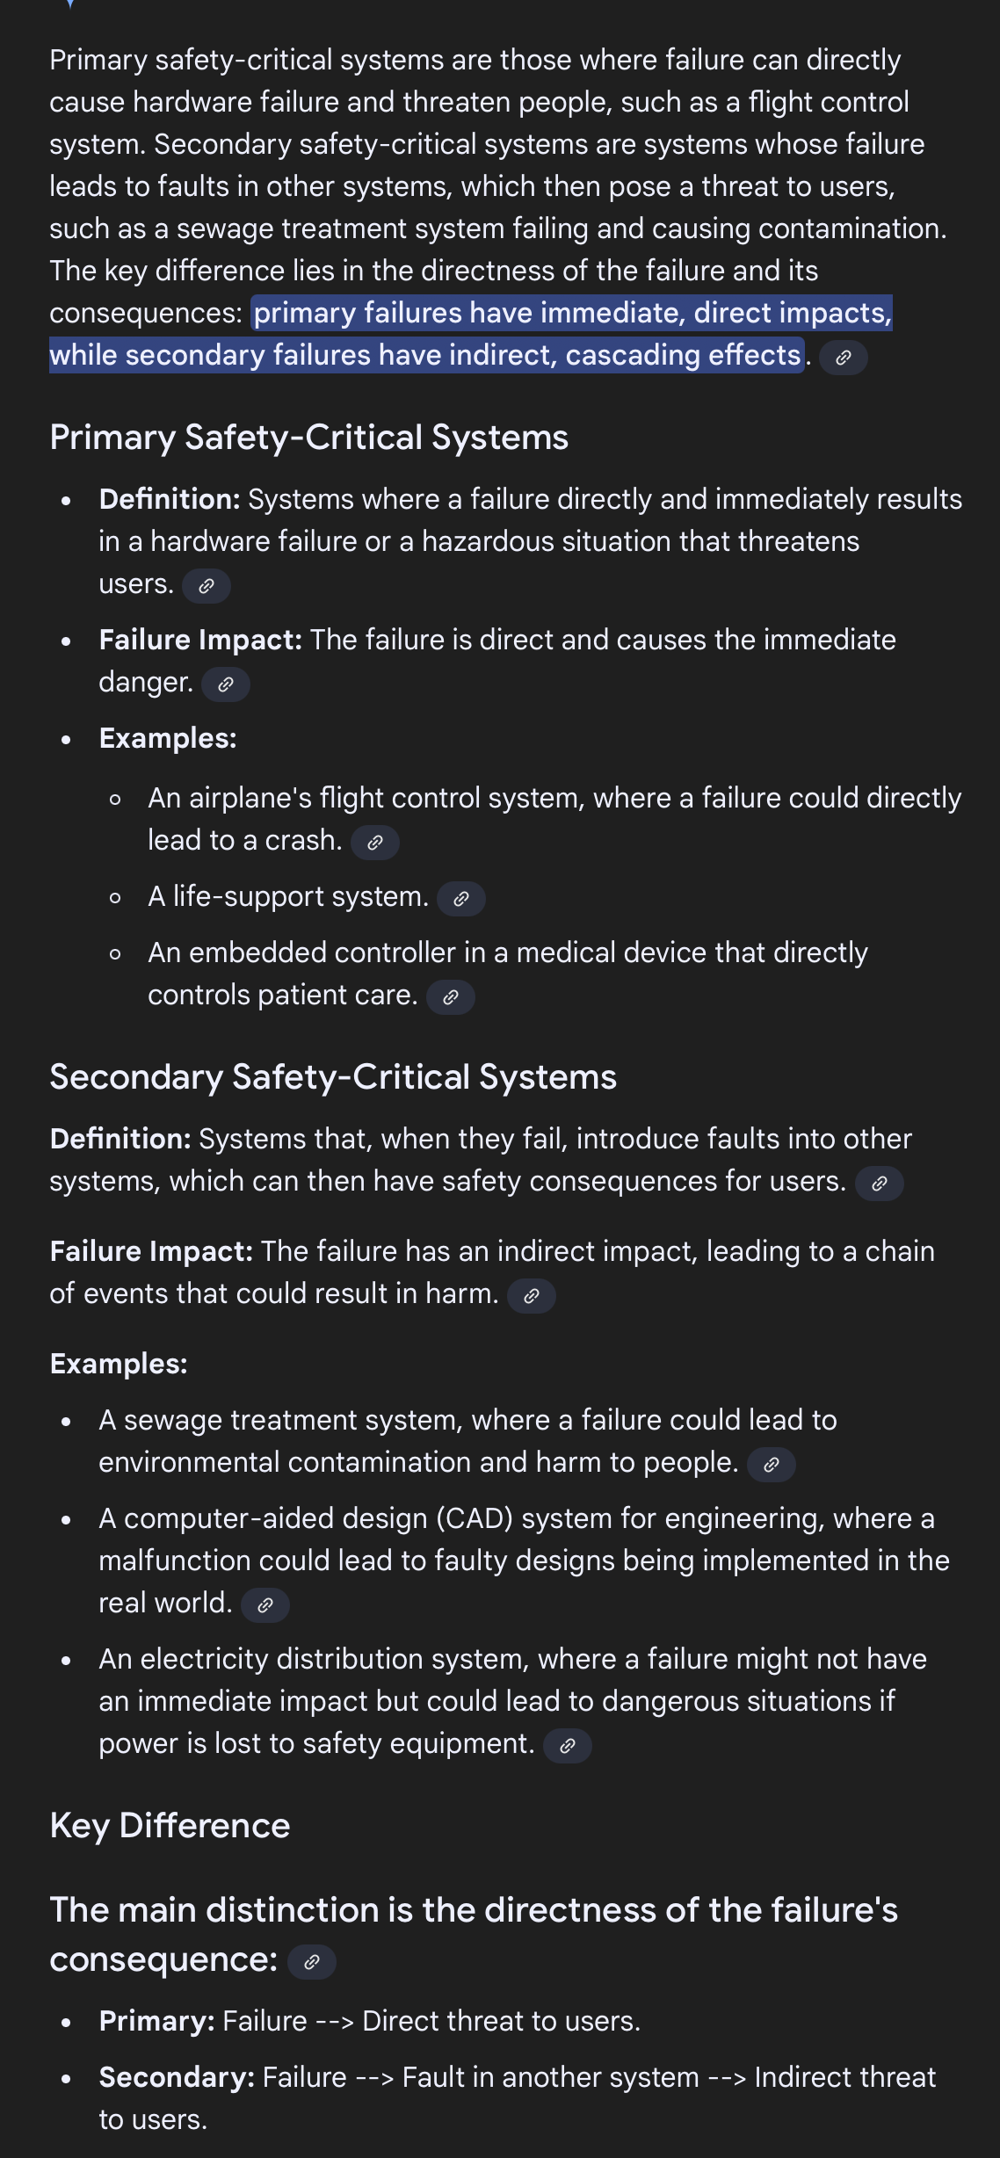

a.
Safety is the most important dimension.
- The system delivers insulin directly to patients. Any incorrect dosage (too high or too low) can cause life-threatening hypoglycemia or hyperglycemia. Therefore, the system must operate in a way that avoids harm, regardless of reliability or availability

b.
It is a Primary Safety-Critical System.
- The failure of the insulin pump directly threatens human life. If the pump malfunctions, the patient could suffer severe complications or death. This is unlike secondary safety-critical systems, which only indirectly cause risks

Question 3 (Leow Yan Luen)

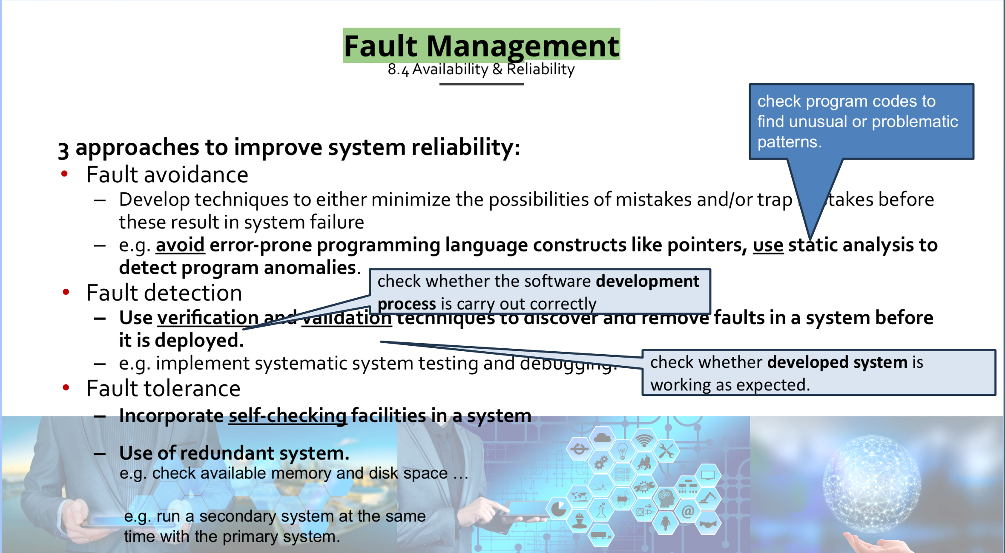

Approach: Fault Detection
- Implement built-in checks to detect errors before they lead to failures.
- Example:
- Include range checks on insulin dosage calculations to ensure they are within safe limits (e.g., not exceeding a maximum dose per hour or per day).
- Use hardware diagnostics (e.g., sensor calibration checks) to detect physical faults.

